Unit 5 test
Vocabulary
Vocabulary
1 Look and tick ().
 | 1 A ☐ hospital  B ☐ hotel
 | 2 A ☐ toy shop  B ☐ supermarket
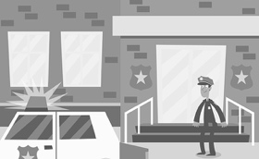 | 3 A ☐ school  B ☐ police station
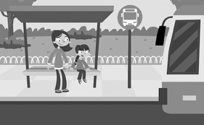 | 4 A ☐ bus stop  B ☐ park
/ 4
2 Look, read and circle.
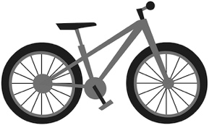 | 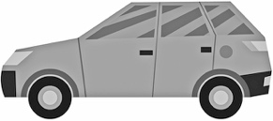 |  |  | 1 train / bike  2 van / car  3 lorry / motorbike  4 van / bike  5 train / car  6 lorry / motorbike
1 | 2 | 3
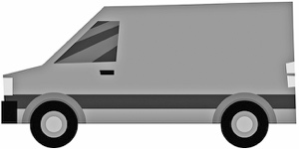 | 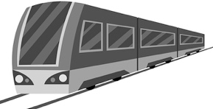 | 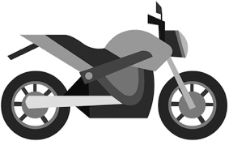
4 | 5 | 6
/ 6

Grammar
3 Look, read and write is, isn’t, are or aren’t.
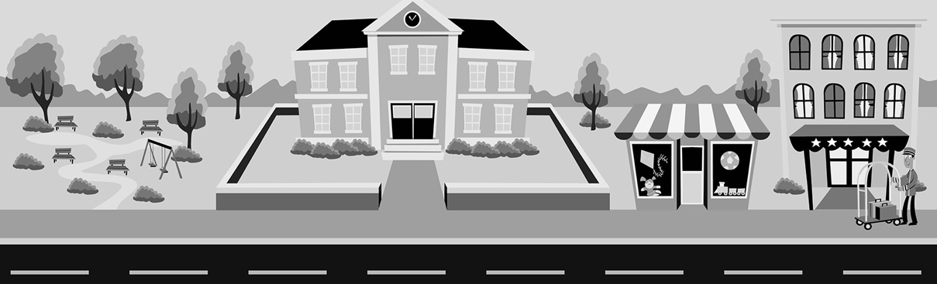
1 Are there any trees? Yes, there .
2 Is there a hospital? No, there .
3 Are there any bus stops? No, there .
4 Is there a hotel? Yes, there .
/ 4
4 Look, read and circle.
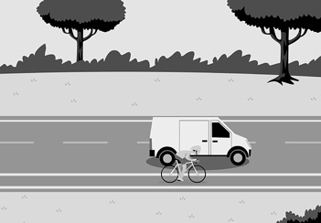 | 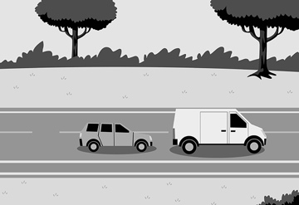 | 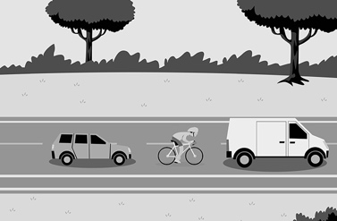
1 Where’s the bike?  It’s next to / behind  the van. | 2 Where’s the car?  It’s in front of / behind the van. | 3 Where’s the bike?  It’s between / behind the van and the car.
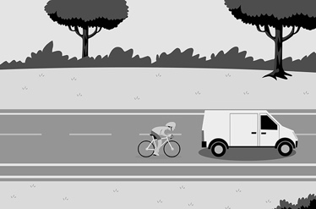 | 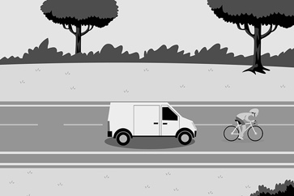 | 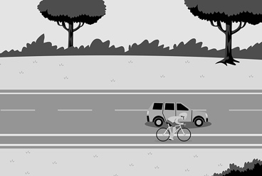
4 Where’s the bike?  It’s next to / behind  the van. | 5 Where’s the bike?  It’s in front of / next to the van. | 6 Where’s the car?  It’s behind / next to  the bike.
/ 6
Reading
5 Read and circle T (true) or F (false).

Transport in your town
Where do you live, Leah?
Westville.
Do you like your town?
Yes, I do. It’s amazing. It’s small. It’s next to lots of trees. It’s got two shops,
but it hasn’t got a hotel.
Is there a tram in your town?
No, there isn’t, but there are buses.
What other transport is there in your town?
There are taxis and people have got cars and bikes, too. I’ve got a red scooter. My sister has got a scooter, too. Her scooter is blue.

1 The survey is about a city. T / F
2 Leah lives in Westville. T / F
3 Leah likes Westville. T / F
4 Westville is big. T / F
5 There are two hotels in Westville. T / F
6 Leah’s scooter is blue. T / F
/ 6
Writing
6 Read and write.
are do isn’t have haven’t
1 Have you got a bike? No, I .
2 you like your city? Yes, I do.
3 your mum and dad got a car? Yes, they have.
4 Is there a bus stop in your street? No, there .
5 there any trams in your city? Yes, there are.
/ 5

Listening
7  5 Listen and write the letter.
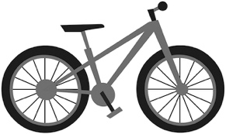 | 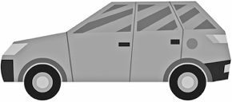 |  |  | 1  2  3  4  5
A | B | C
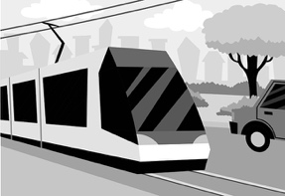 | 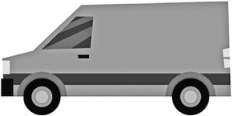
D | E
/ 5
Speaking
8 Look and answer. What transport is in your town?
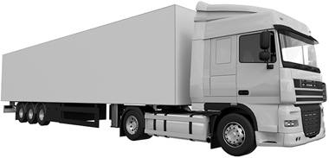 | 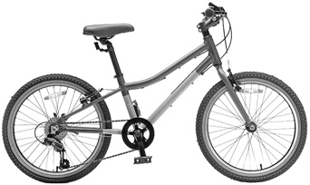 |  | 1 Are there any lorries?  2 Are there any bikes?  3 Are there any cars?  4 Are there any trains?
1 | 2
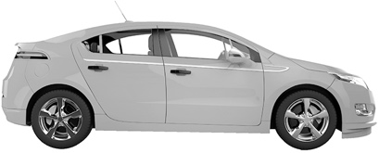 | 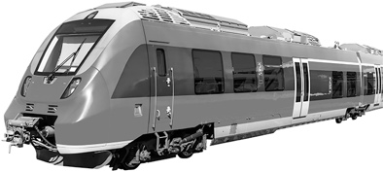
3 | 4
/ 4
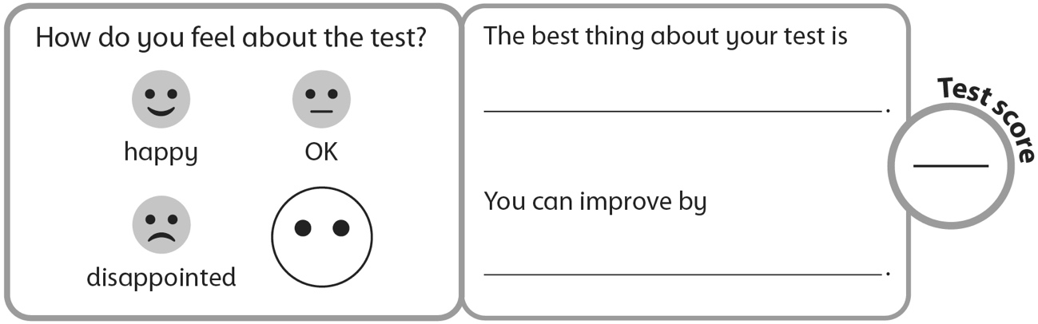
40

